Parallel Programming

CS575

Chao Zhang

Project #4

1. Source listing

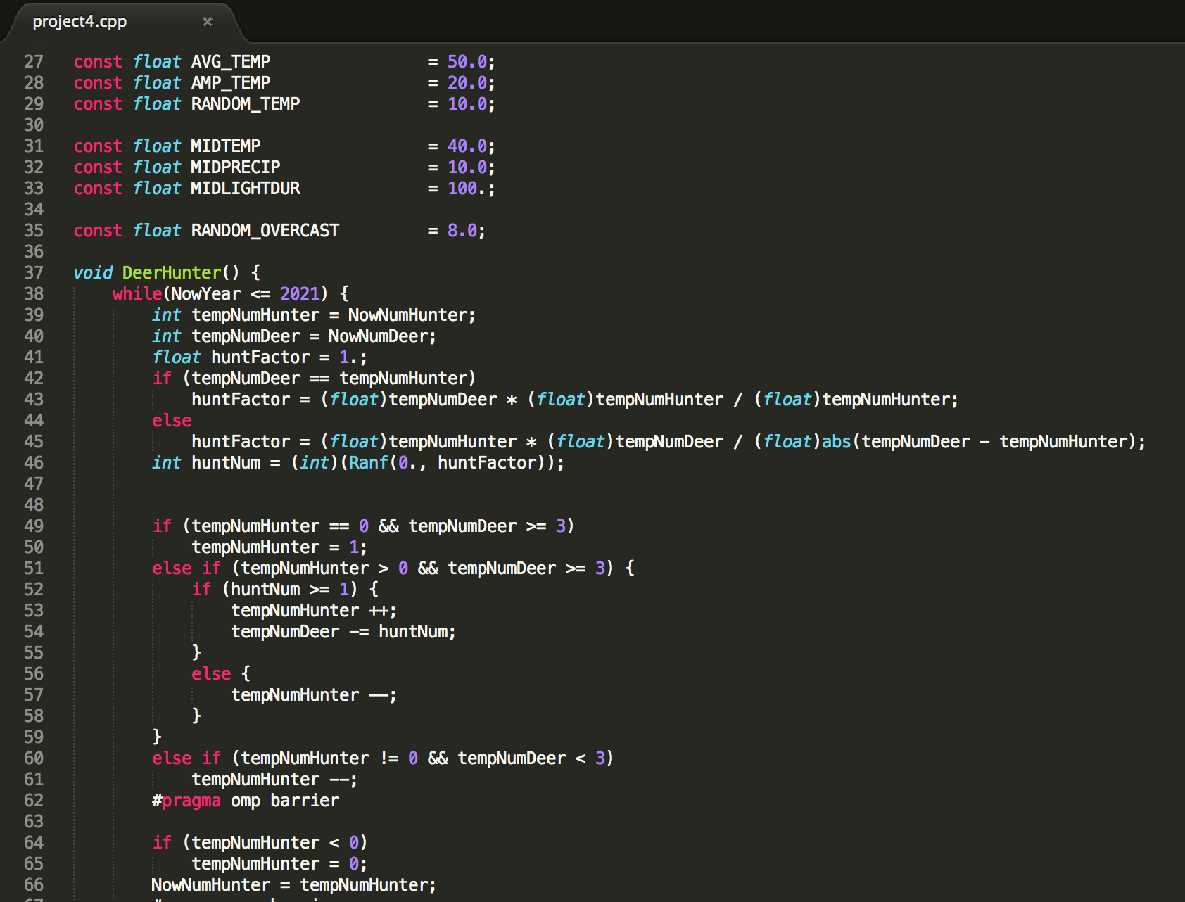

This is the code of myagent, I named my agent as the DeerHunter. The hunter will start hunting the deer when there has three or more than three deer. The hunter has the same number as the deer in the beginning. Like the real, the number of hunters will decreased by one if they didn’t hunt any deer in a month because of the 0 income.

1. Result and analysis

Because of the data is to long in one table, so I make them separated by year.

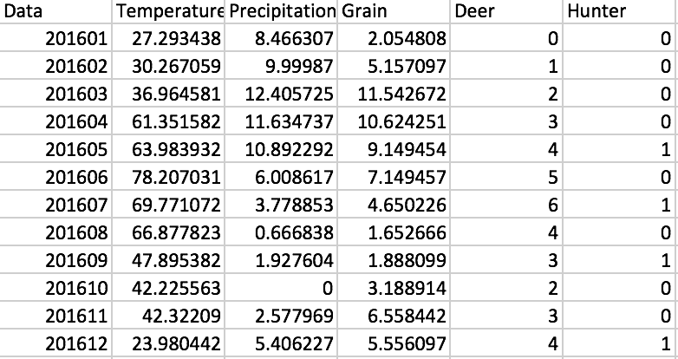

Table for 2016

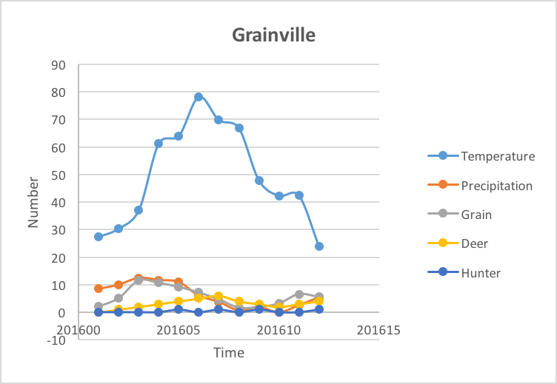

Graph for 2016

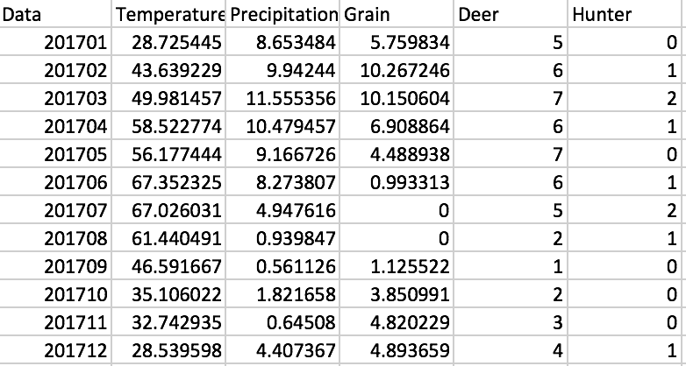

Table for 2017

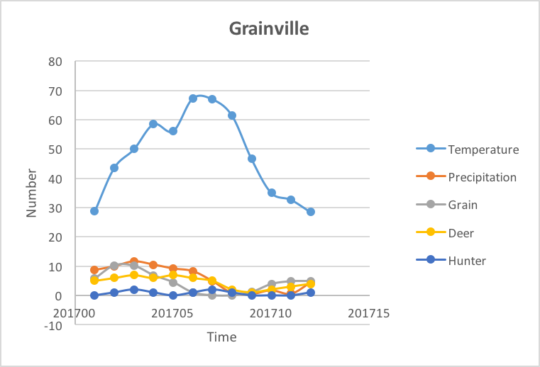

Graph for 2017

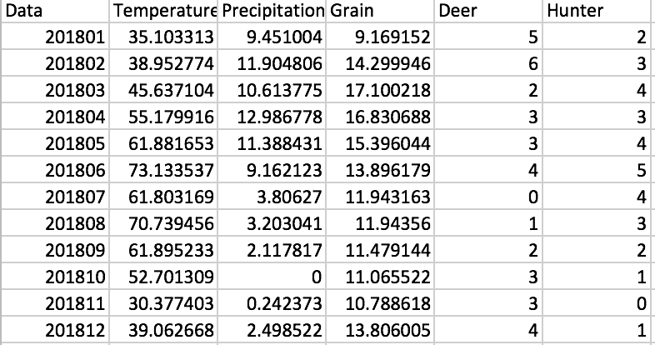

Table for 2018

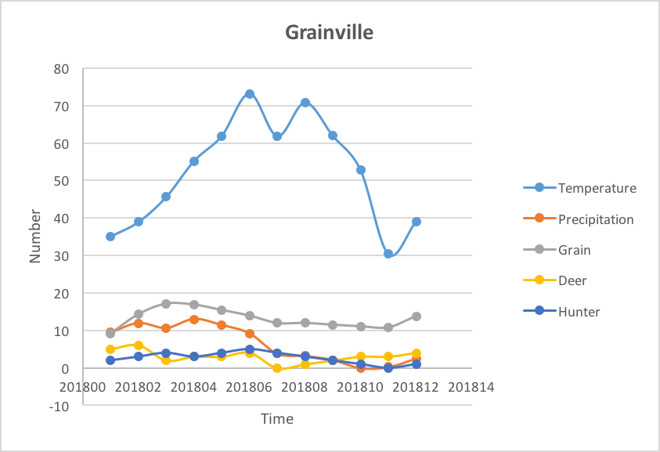

Graph for 2018

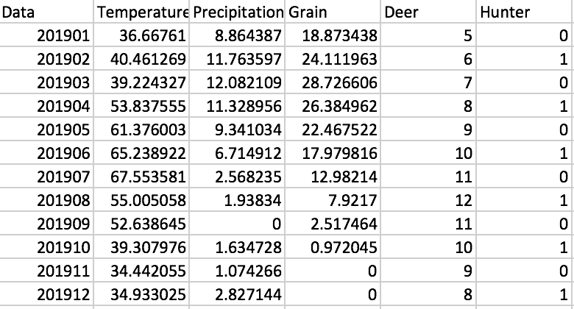

Table for 2019

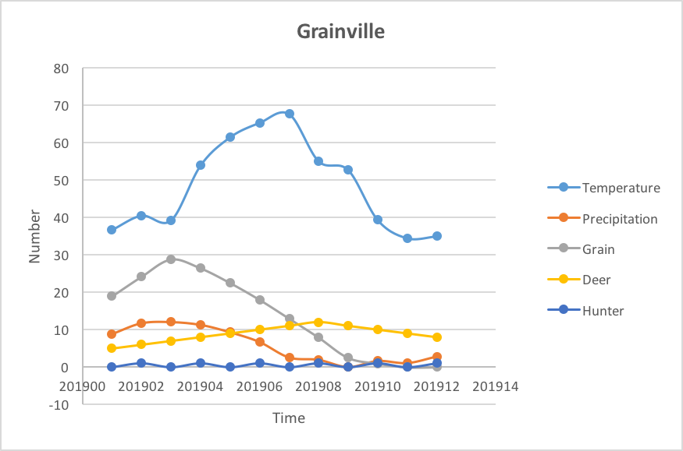

Graph for 2019

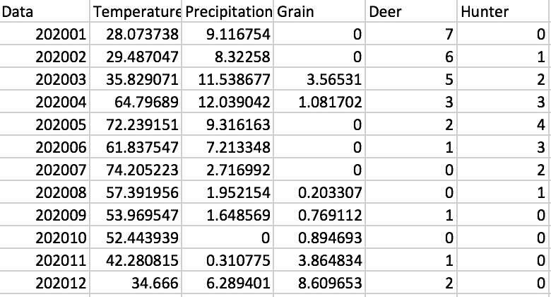

Table for 2020

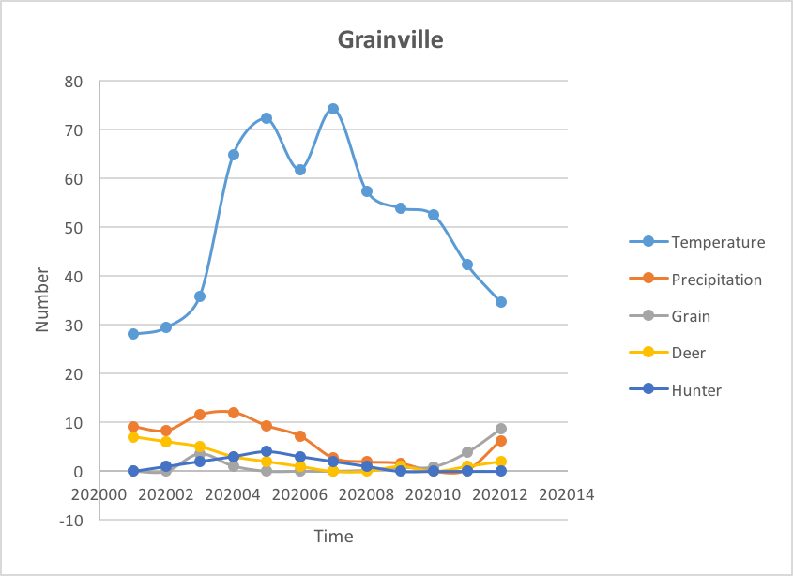

Graph for 2020

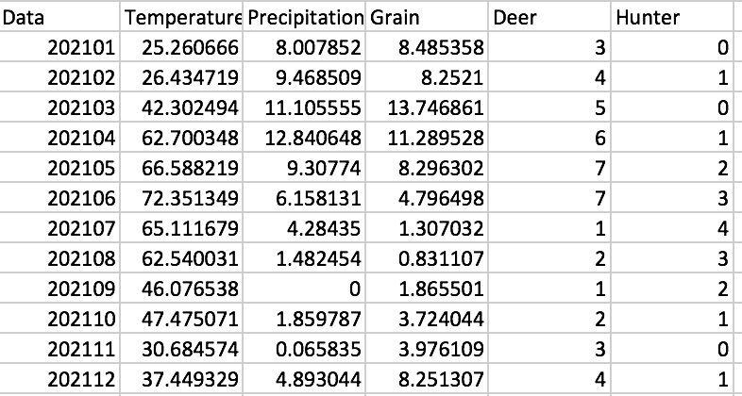

Table for 2021

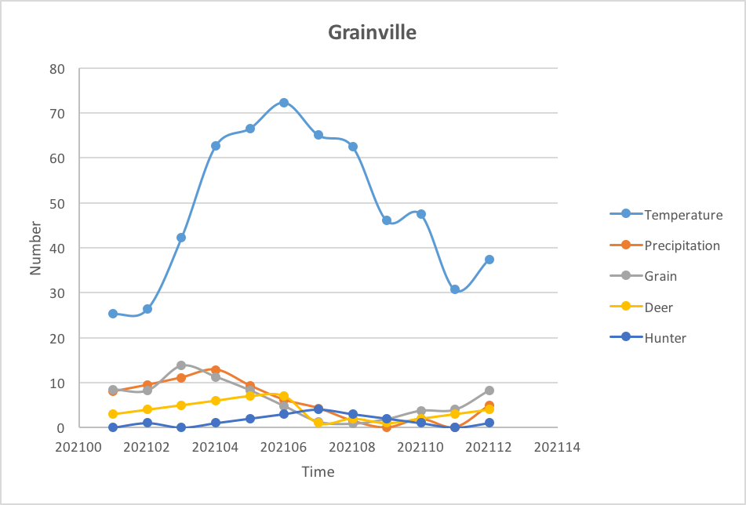

Graph for 2021

For the results we can get that the height of the grain is related to the temperature, the precipitation, and the number of deer. It goes down with the growth of the number of deer, almost the same as the precipitation, and can be highest with a specified temperature. The number of hunter is related to the number of deer. When we have many deer, the hunter will increase and with the increase of hunter, the number of deer goes down. All of those works like this because the 3 threads work. All the thread read and write the current and the global variables as they should. So all of those factors effect each other.